**Article**

**Results of the 2023 ASEAN Summit**

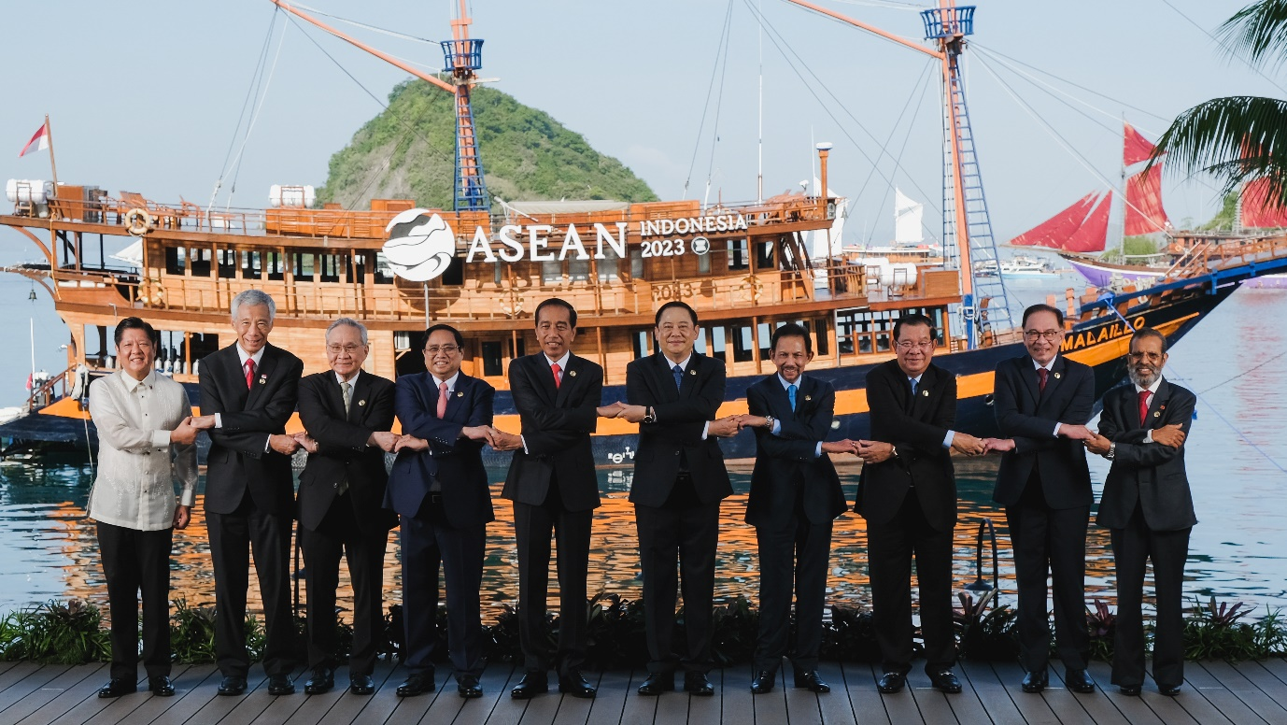

*ASEAN leaders pose for a group photo at the 42nd ASEAN Summit, Labuan Bajo, Indonesia. (from left-right) President of the Philippines Ferdinand R. Marcos Jr., Prime Minister of Singapore Lee Hsien Loong, Deputy Prime Minister/Minister of Foreign Affairs of Thailand Don Pramudwinai, Prime Minister of Vietnam Pham Minh Chinh, President of Indonesia Joko Widodo, Prime Minister of Laos Sonexay Siphandone, Sultan of Brunei Darussalam Sultan Haji Hassanal Bolkiah, Prime Minister of Cambodia Hun Sen, Prime Minister of Malaysia Dato' Seri Haji Anwar Ibrahim, Prime Minister of Timor Leste Taur Matan Ruak (Photo credit: ASEAN2023 Host Photographer)*

The 42nd ASEAN Summit in 2023 in Labuan Bajo, East Nusa Tenggara, was held on 10-11 May 2023. The results of the 42nd ASEAN Summit have resulted in several agreements on various issues discussed and delivered by President Joko Widodo.

As Chair of ASEAN 2023, Indonesia has prepared several issues to be brought up and discussed with leaders of countries in the Southeast Asian region. Several issues negotiated at the 42nd ASEAN Summit are chair statements, post-2025 vision, Timor Leste membership, Myanmar crisis, prevention of human trafficking, migrant workers, fishery workers, health sector, electric vehicles, strengthening ASEAN capacity, and cross-border payments.

The points of agreement from the 2023 ASEAN Summit are:

**1. The War on Human Trafficking**

ASEAN leaders agreed to work together, coordinate, and collaborate on the Crime of Human Trafficking due to the misuse of technology through various regional mechanisms and ASEAN initiatives.

It includes increasing law enforcement in each member country and related agencies carrying out capacity to investigate, collect data and evidence, identify victims, and joint investigations related to human trafficking.

**2. Settlement of the Myanmar Crisis**

By acclamation, ASEAN leaders jointly supported President Joko Widodo for the attack on the regional humanitarian aid team (AHA) Center and the ASEAN Oversight Team in Hseng Township, Shan State, northern Myanmar. All countries are pushing for the Five-Point Consensus implementation to resolve the Myanmar crisis immediately with a solution that promotes justice and peace.

**3. Development of the Electric Vehicle Ecosystem**

The 2023 ASEAN Summit agreed on electric vehicle use to reduce greenhouse gas emissions, accelerate energy transitions, decarbonize the land transportation sector in the Southeast Asian region, achieve Net Zero Emissions, and increase energy security in each ASEAN member country. Representatives of ASEAN countries share the same commitment to developing a regional electric vehicle ecosystem by involving all ASEAN members. The Association of Southeast Asian Nations is working to boost the electric vehicle industry and make ASEAN a global production hub.

**4. Payment Connectivity**

ASEAN leaders are starting to set up cross-border digital payment innovation opportunities. In addition, it also encourages the use of local currency for regional transactions carried out to support the role of financial sector authorities. Further cooperation is needed to advance regional payment connectivity while facilitating the interoperability of cross-border payment systems. Apart from that, ASEAN leaders must improve infrastructure, accelerate the adoption of digital payments, develop human resources, strengthen cyber security, and others.

**5. Protection of Migrant Workers**

ASEAN leaders also agreed to protect migrant workers with policies to assist cross-area migrant workers, especially women, and families in crises. In addition, ASEAN country leaders agreed to provide protection and migrant worker rights, such as health care, psychosocial support, social and livelihood support when on leave, illness or injury, and return to their countries of origin.

The agreement reached the 42nd ASEAN Summit is in line with the aim of ASEAN centrality to make it stronger and more independent. President Joko Widodo appreciated the 42nd ASEAN Summit in Labuan Bajo, Nusa Tenggara Tinggi, which had run smoothly and provided good points of agreement. Apart from having introduced Labuan Bajo as Indonesia's Super Priority Destination in the eyes of foreign countries, the 42nd ASEAN Summit also gave good memories and impressions to ASEAN leaders.

Through the 42nd ASEAN Summit, Indonesia, as chairman this year, wants to see ASEAN getting stronger, capable of facing challenges, responsive to dynamics, and still holding a central role in the region. The 42nd ASEAN Summit 2023 results are concrete and beneficial, in line with the three pillars of Indonesia's Chair for ASEAN 2023.

Three main pillars in the theme “ASEAN Matters: Epicentrum of Growth" are ASEAN Matters, Epicentrum of Growth, and related to the Implementation of the ASEAN Outlook on the Indo-Pacific (AOIP).

In addition, the President also emphasized that ASEAN is a family with strong ties and united with the same goal, to make ASEAN a center of growth and a region of peace, stability, and prosperity.

**#ASEANMatters**

**#ASEANIndonesia2023**

**#ASEANEpicentrumofGrowth**